Create a CRUD Master-Detail app using the template provided by SAP Web IDE, and get it ready to be built as a hybrid app.

You will learn
- How to configure a destination
- How to choose the SAP Web IDE template and create the app

Prerequisites
- Tutorials: Sign up for a free trial account on SAP Cloud Platform

Step 1: Log in to SAP Cloud Platform
Go to https://cockpit.hanatrial.ondemand.com and log in to your SAP Cloud Platform cockpit and select Enter Your Trial Account.
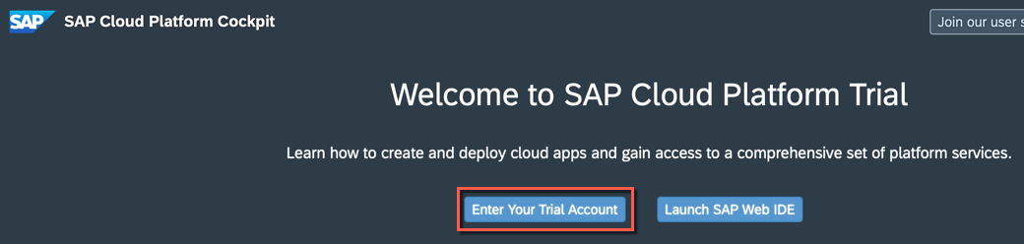
SAP offers SAP Cloud Platform Trial on both Cloud Foundry as well as Neo. For this tutorial and the subsequent mobile tutorial please select the Neo Trial environment. On the cockpit page, scroll down to the Environments section and select Access Neo Trial.
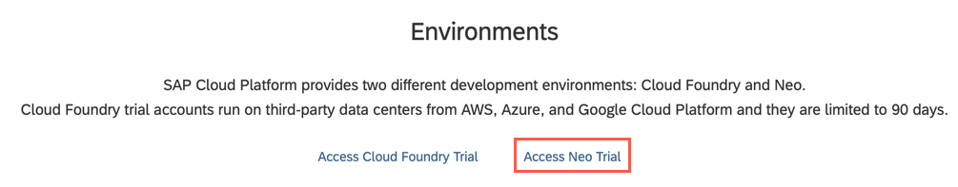

Done

Log on to answer question
Step 2: Enable Mobile Services
Choose Services on the left pane, scroll down and then choose Mobile Services, users. You can also search for mobile.
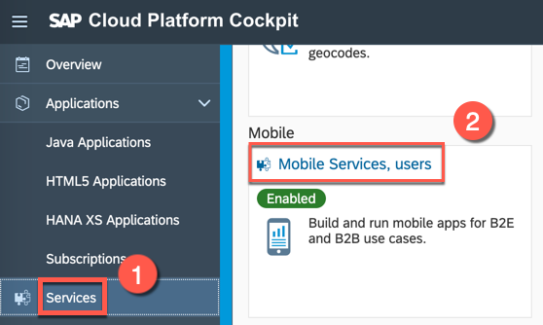
On the Service: Mobile Services, users - Overview page, click Enable.
Use this service to access the destination that you create, and to build your app as a mobile app using the cloud build service.

Done

Log on to answer question
Step 3: Create new destination
In the left pane, select Connectivity > Destinations, then click New Destination to open a new Destination Configuration form.
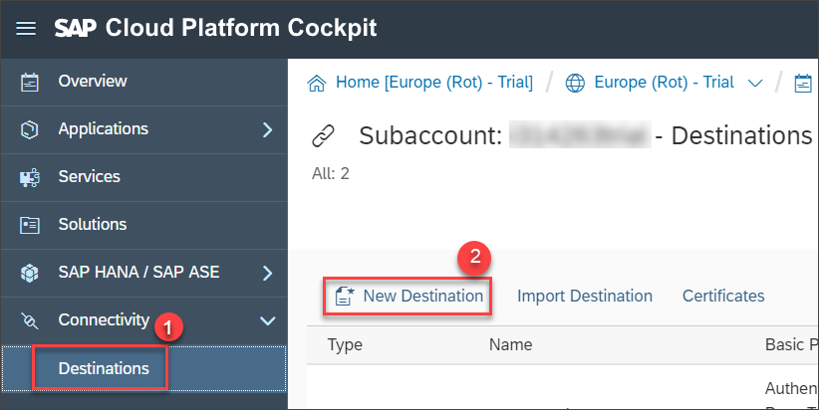
Provide the following configuration values for the new destination:
Field Name | Value
Name | MobileServiceSampleData
Type | HTTP
Description | Mobile Service Sample OData Service
URL | https://hcpms-<your account number>trial.hanatrial.ondemand.com/mobileservices/origin/hcpms/ESPM.svc/v2
Proxy Type | Internet
Authentication | App2AppSSO
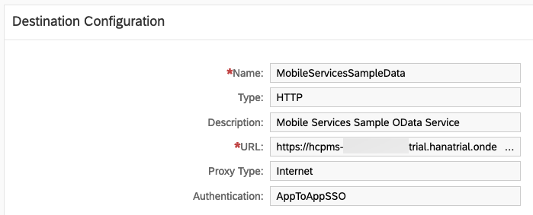
Add the following additional properties by clicking the New Property button once for each property:
Field Name | Value
WebIDEEnabled | true
WebIDEUsage | odata_gen
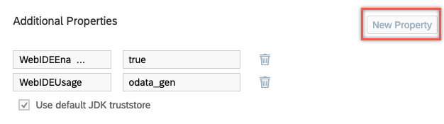
Click Save.
Select the value of the Web IDE Usage parameter in your destination from the list below and click Validate:odata_abapodata_gentrue
Submit Answer
×
Log on to answer question
Step 4: Open SAP Web IDE Full-Stack
In the left pane, choose Services, scroll down and choose Web IDE Full-Stack.
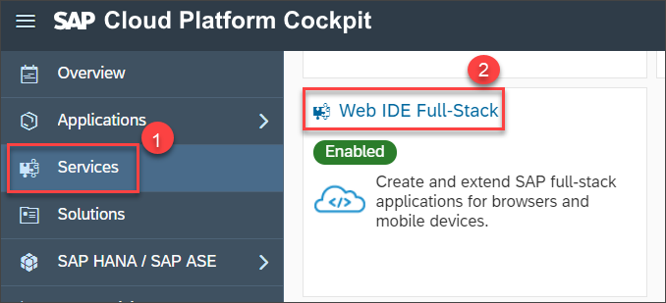
From the Service: Web IDE Full-Stack - Overview page, choose Go to Service to open Web IDE Full-Stack in a new browser tab.
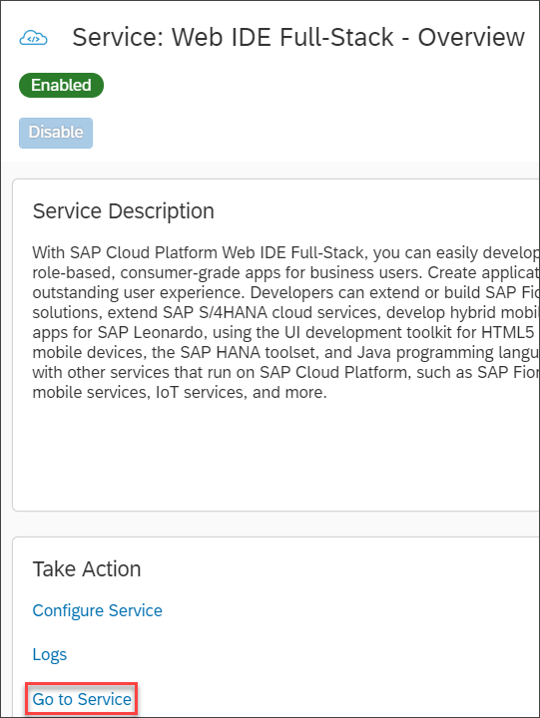
If you can’t select Go to Service, it means the Web IDE Full-Stack service isn’t enabled for your account. On the Service: Web IDE Full-Stack - Overview page, choose Enable to enable the service and then repeat the above step.

Done

Log on to answer question
Step 5: Choose a new project template
In SAP Web IDE, please Select File > New > Project from Template.On the Template Selection page, choose Neo from the Environment list and All Categories from the Category list.From the displayed templates, choose the CRUD Master-Detail Application template and select Next.
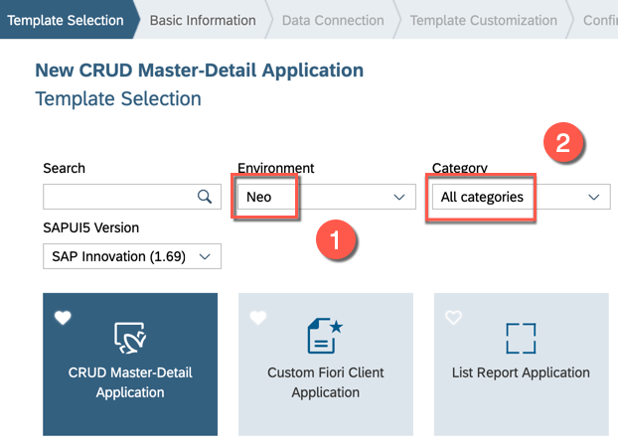

Done

Log on to answer question
Step 6: Enter basic project information
On the Basic Information page, provide the following information:
Field Name | Value
Project Name | OfflineCRUDDemo
Title | Offline CRUD Demo App
Namespace | com.sap.offlinecruddemo
Description | Demo app to showcase offline capabilities
Select Next.
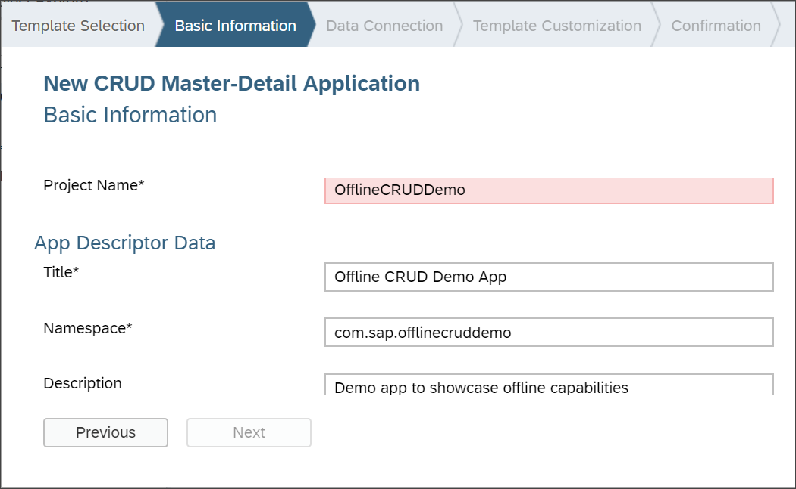

Done

Log on to answer question
Step 7: Configure data connection
On the Data Connection page, choose Service URL as the service source. If you only have one WebIDEEnabled destination in SAP Cloud Platform, it is automatically selected. If you don’t see the MobileServiceSampleData service selected (the destination you created in step 3), click the dropdown menu and select it.
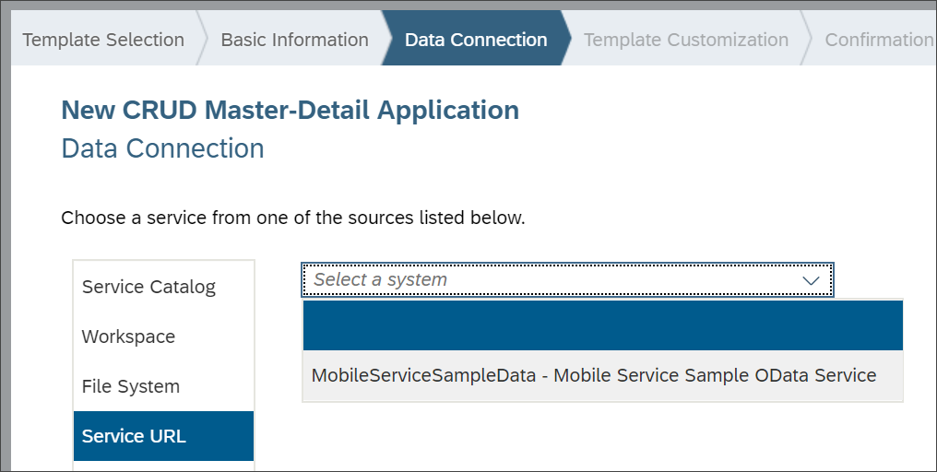
If the MobileServiceSampleData service doesn’t appear in the dropdown menu, return to your destination in the SAP Cloud Platform cockpit and double-check the entries from step 3. If you make changes, reload Web IDE and repeat the procedure from step 5 in this tutorial.

Done

Log on to answer question
Step 8: Test the data connection
Enter /mobileservices/origin/hcpms/ESPM.svc/v2 as the relative URL and select Test.
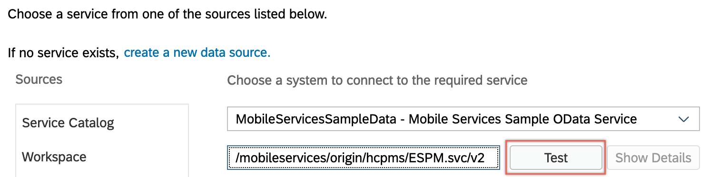
You should see the data from the service.
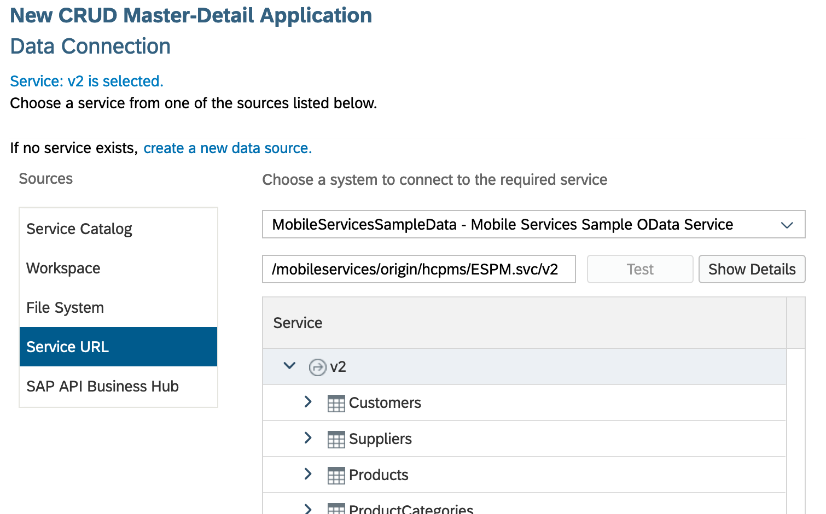
Select Next.

Done

Log on to answer question
Step 9: Customize the template
In the Data Binding - Object section, enter the following values:
Field Name | Value
Object Collection | Suppliers
Object Collection ID | SupplierID
Object Title | SupplierName
Object Unit of Measure | PhoneNumber
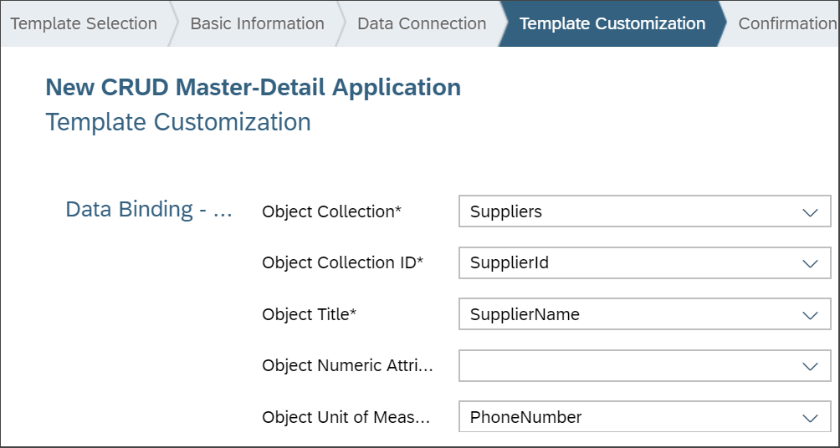
In the Data Binding - Line Item section, enter the following values:
Field Name | Value
Line Item Collection | Products
Line Item Collection ID | ProductID
Line Item Title | Name
Line Item Numeric Attribute | Price
Line Item Unit of Measure | CurrencyCode
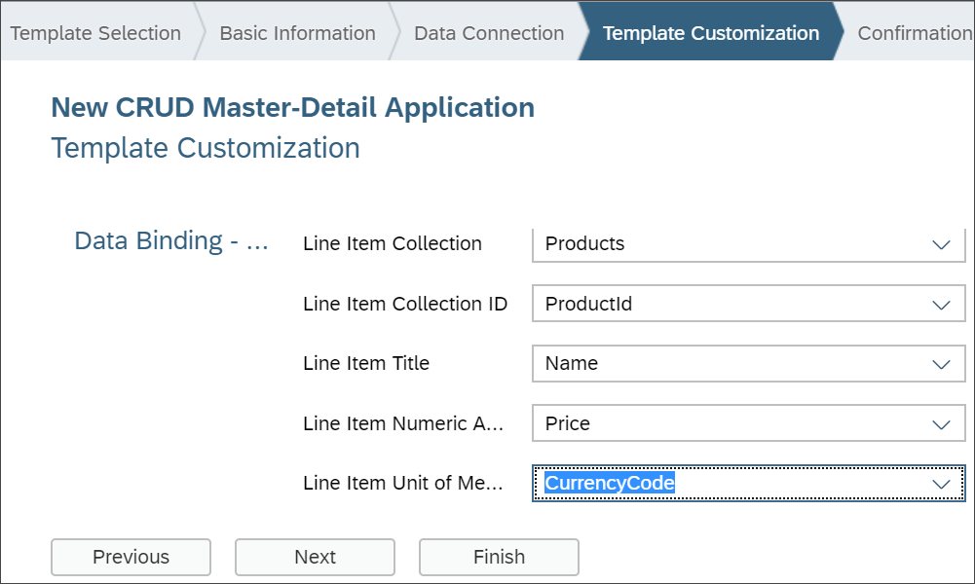

Done

Log on to answer question
Step 10: Generate the app
Select Finish to create the new CRUD app. After the app is generated, select the OfflineCRUDDemo project folder icon to see the project structure.
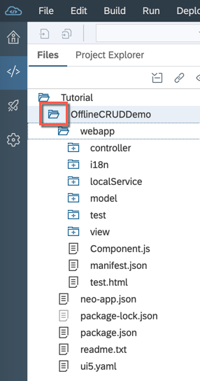

Done

Log on to answer question
Step 11: Run the app
Under the OfflineCRUDDemo project folder icon, choose the test.html file and select Run.
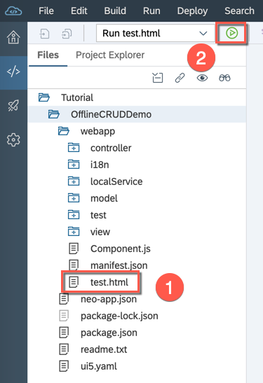
On the Testing Overview page, choose test/flpSandbox.html to launch the app.
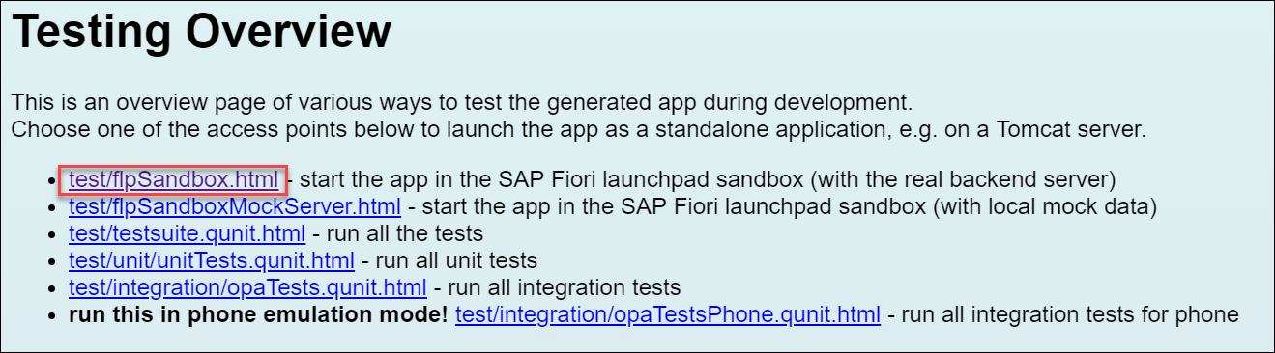
Your app opens in a Web IDE preview pane.

